**Entity Relationship Diagrams**

From the last lesson, you might remember that an **entity relationship diagram** (ERD) is a common way to view data in a database. It is also a key element to understanding how we can pull data from multiple tables.

It will be beneficial to have an idea of what the ERD looks like for Parch & Posey handy, so I have posted it again below. **You might even print a copy to have with you as you work through the exercises in the remaining content.**

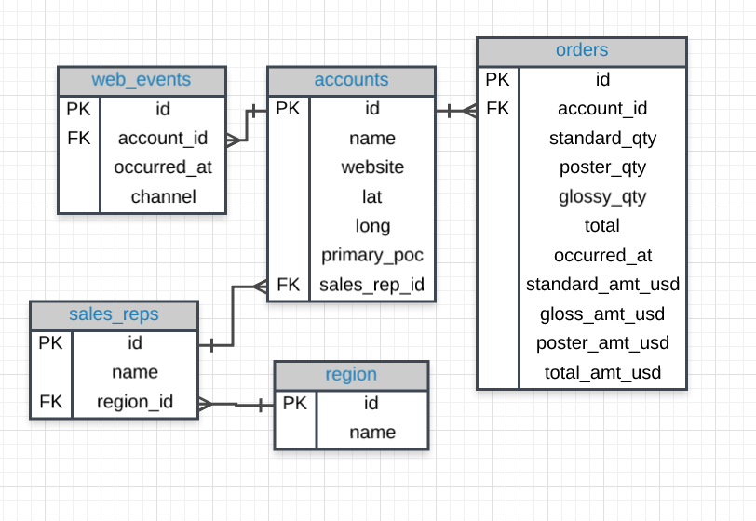

**Tables & Columns**

In the Parch & Posey database there are 5 tables:

1. **web_events**
2. **accounts**
3. **orders**
4. **sales_reps**
5. **region**

You will notice some of the columns in the tables have **PK** or **FK** next to the column name, while other columns don't have a label at all.

If you look a little closer, you might notice that the **PK** is associated with the first column in every table. The **PK** here stands for **primary key**. **A primary key exists in every table, and it is a column that has a unique value for every row.**

If you look at the first few rows of any of the tables in our database, you will notice that this first, **PK**, column is always unique. For this database it is always called id, but that is not true of all databases.

You can explore the database ERD below by clicking on the table names in the left menu of the workspace below. Or you can query the first row of these tables in the workspace to see some examples of the content inside of each field.